 | 10.1.6 Editors - Compositor Editor - Header - Add Menu - Input
Table of content
Detailed table of content 1
Add menu - Input 4
Blank Image 4
Bokeh Image 4
Image 5
Image Info 9
Image Coordinates 9
Mask 10
Movie Clip 11
String to Image 12

Detailed table of content

Detailed table of content
Detailed table of content 1
Add menu - Input 4
Blank Image 4
Inputs 4
Color 4
Size 4
Output 4
Bokeh Image 4
Inputs 5
Flaps 5
Angle 5
Rounding 5
Catadioptric 5
Color Shift 5
Outputs 5
Image 5
Image 5
Properties 5
Image Property 5
List of images in the scene 6
Search form 6
Image Edit Box 6
Number of Fake Users 6
Fake User 6
Open 6
New 6
Name 6
Width 6
Height 6
Color 6
Alpha 6
Generated Type 7
32 Bit Float 7
Tiled 7
Source 7
Single Image 7
Color Space 7
Alpha 7
Image Sequence + Movie 7
Frames 7
Start Frame 7
Offset 8
Cyclic 8
Auto-Refresh 8
Color Space 8
Alpha 8
Generated 8
Color Space 8
UDIM Tiles 8
Color Space 8
Alpha 9
Image Info 9
Inputs 9
Image 9
Outputs 9
Dimensions 9
Resolutions 9
Location 9
Rotation 9
Scale 9
Image Coordinates 9
Inputs 9
Image 9
Outputs 9
Uniform 9
Normalized 10
Pixel 10
Mask 10
Properties 10
Masks 10
Size X / Y 10
Feather 10
Motion Blur 10
Samples 10
Shutter 10
Outputs 10
Mask 10
Movie Clip 11
Properties 11
Movie Clip 11
File browser 11
Name 11
Fake User 11
Load File 11
Delete File 11
Outputs 11
Image 11
Alpha 11
Offset X 12
Offset Y 12
Scale 12
Angle 12
String to Image 12
Properties 12
String 12
Font 12
Size 12
Alignment 12
Wrap 12
Width 13
Output 13

Add menu - Input
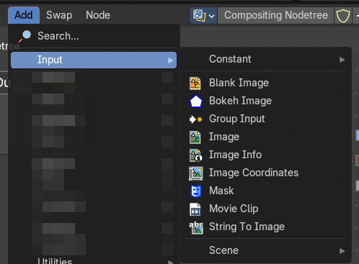
The Input menu contains Input node types.

The content is the same for all three sub modes. Note that you need to tick Use Nodes to activate the menu items when you are in Line Style sub mode.

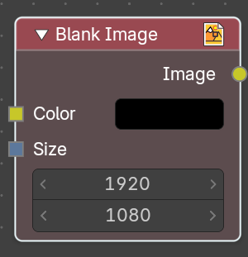
Blank Image
The Blank Image node generates a solid image of a chosen size and color. It is used as a base layer, background plate, or placeholder in compositing workflows, allowing to create flat color fields or masks without importing external images.

Inputs

Color
Defines the fill color of the image. Chosen through a swatch or color picker, supporting any RGB value. Determines the visual appearance of the generated blank image.

Size
Specifies the resolution of the image in pixels. Allows matching render dimensions or creating custom aspect ratios.

Output
Produces a standard image that can be connected to other compositor nodes. This can be layered with Mix or Alpha Over, processed with filters, or used as a mask source.

Bokeh Image
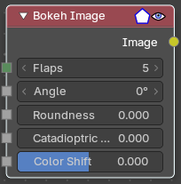
The Bokeh Image node generates a special input image for use with the Bokeh Blur filter node.
The Bokeh Image node is designed to create a reference image which simulates optical parameters such as aperture shape and lens distortions which have important impacts on bokeh in real cameras.

Inputs
The first three settings simulate the aperture of the camera.

Flaps
Sets an integer number of blades for the cameras iris diaphragm.

Angle
Gives these blades an angular offset relative to the image plane.

Rounding
Sets the curvature of the blades with (0 to 1) from straight to bringing them to a perfect circle.

Catadioptric
Provides a type of distortion found in mirror lenses and some telescopes. This can be useful to produce a visual complex bokeh.

Color Shift
Introduces chromatic aberration into the blur such as would be caused by a tilt-shift lens.

Outputs

Image
The generated bokeh image.

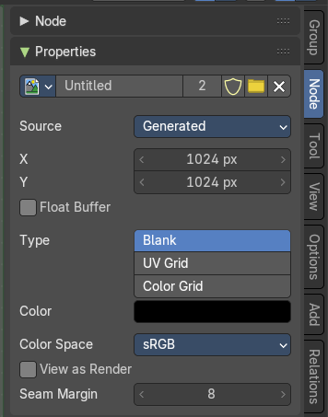
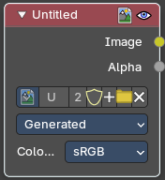
Image
Image input. For further image settings see also the Properties Panel in the Node Tab in the Sidebar. It contains the same settings than the image types in the image and uv editor.

Properties

Image Property
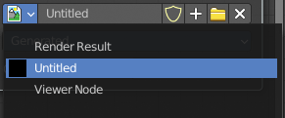
This property contains the list of loaded images. When no image is loaded then it displays the New and Open Buttons. When an image exists then it displays the name of the currently selected image.

From left to right ...

List of images in the scene
This is a list of the images in the scene. This list allows you to switch to other images.

Search form
Search for specific images.

Image Edit Box
Read the name of the currently selected image. And you can rename the image here too.

Number of Fake Users
In case this file has a fake user assigned, then this number displays the number of fake users.

Fake User
Wit this button you assign a fake user to this selected image.
Data, like images, that is not longer linked to anything else gets removed when you save and reload a scene. Bforartists has the concept of fake users to go around this behavior. An image with a fake user is in fact linked to something. And so it is not lost when you save and reload the scene.

Open
Open a new image.

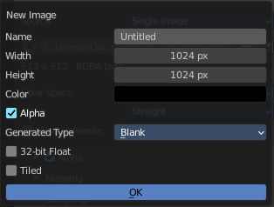
New
Create a new image.
Creates a new image. You will get a dialog where you can define settings for the new image.

Name
The name of the new image

Width
The width of the new image.

Height
The height of the new image.

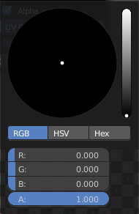
Color
Adjust the color of the new image. A click will call a color picker.

Alpha
Check this checkbox if the new image should have an alpha channel.

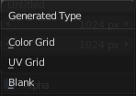
Generated Type
Here you can define what kind of texture you want to create.
Blank is one plain color.
UV Grid is a checker texture in black and white.
Color Grid is a colored checker texture.

32 Bit Float
Check this checkbox if the image should be in 32 Bit floating point bit depth per channel. Else it is in 8 bit per channel.

Tiled
Create a tiled image.

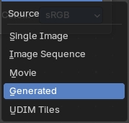
Source
What kind of source image to use.

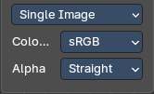
Single Image

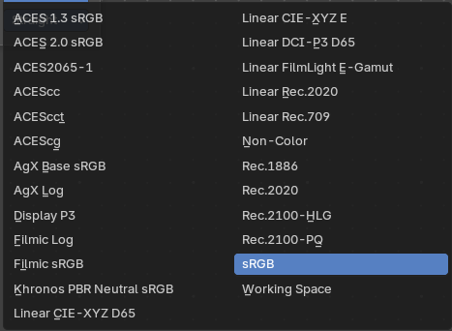
Color Space
The color space for the image.

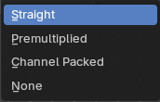
Alpha
The alpha channel mode.

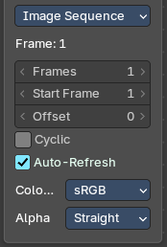
Image Sequence + Movie

Frames
Number of images to use

Start Frame
The start frame

Offset
Offset the nubmer of the frame to use in the animation.

Cyclic
Cycle the images in the image sequence / Movie.

Auto-Refresh
Always refresh images on frame changes.

Color Space
The color space for the image.

Alpha
The alpha channel mode.

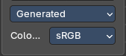
Generated

Color Space
The color space for the image.

UDIM Tiles

Color Space
The color space for the image.

Alpha
The alpha channel mode.

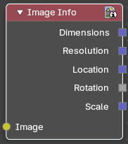
Image Info
Returns informations about an image.

Inputs

Image
The input image.

Outputs

Dimensions
The dimensions output value.

Resolutions
The resolutions output value.

Location
The locations output value.

Rotation
The rotation output value.

Scale
The scale output value.

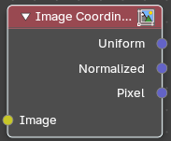
Image Coordinates
Returns the coordinates of the pixles of an image

Inputs

Image
The input image.

Outputs

Uniform
Zero centered coordinates normalizes along the larger dimension for uniform scaling.

Normalized
Normalized coordinates with half pixels offset.

Pixel
Integer pixel coordinates.

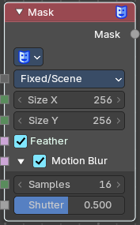
Mask
The Mask node can be used to select a Mask data. This node can be used with other nodes, for example to Invert, Multiply or Mix, or used as a factor input.
Masks can be created in the Image and Movie Clip editors, by changing the mode to Mask in the header. So you first need to create one in one of those editors.

Properties

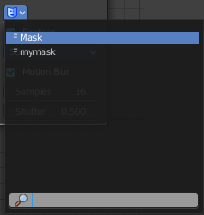
Masks
The available mask data. If the label is left blank, the mask name will be set.

Size X / Y
The resolution of the mask

Feather
Use or ignore feather points defined for splines see Mask Feathers for more details.

Motion Blur
For animated masks, creating a motion blurred mask from the surrounding frames, with a given number of samples (higher gives better quality), and a camera shutter time in seconds.

Samples
The number of motion blur samples.

Shutter
Expose for motion blur as a factor of Frames per Seconds.

Outputs

Mask
The black-and-white output of the mask.

hier weiter

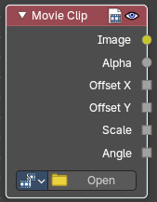
Movie Clip
This node is a special node that uses some of the values taken from footage cameras and trackings and links them to the output. It is possible to load image sequences, but only Image and Alpha values will be available, because the other outputs will not have any values associated with them. When a tracked clip is chosen, Blender will fulfill the outputs using internal values taken from the tracking. So the controls for start and end frames will be defined at the Movie Clip editor.

Properties

Movie Clip
Select the movie clip.
Once loaded you will see a preview image of the movie. Scrolling through the timeline will display the corresponding frame in this preview image.

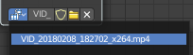
File browser
Choose an already loaded video.

Name
Read and edit the name of the video.

Fake User
Assign a fake user to this video. Fake users is an odd concept to keep data in the scene even if it has no user somewhere. The fake user is then a dummy user so that the object is not deleted when saving the scene.

Load File
Load a new video.

Delete File
Delete this video.

Outputs

Image
Outputs the entire image at the specified color space.

Alpha
The alpha value taken from the movie or image.

Offset X
The X offset value from the footage camera or tracking.

Offset Y
The Y offset value from the footage camera or tracking.

Scale
The scale of the image taken from the footage camera or tracking.

Angle
The lens angle taken from the footage camera or tracking.

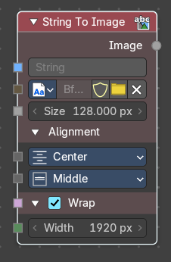
String to Image
Converts a text string into an image buffer directly inside the compositor. Useful for overlaying text, generating procedural titles, or integrating dynamic labels into compositing workflows without external text objects.

Properties

String
Input field for the text content. Accepts plain text or dynamic string inputs. Can be used for captions, labels, or procedural text overlays.

Font
Dropdown or file selector for choosing the font datablock. Supports internal packed fonts and external font files. Ensures consistent typography across compositing setups.

Size
Defines the pixel size of the rendered text. Larger values = bigger text. Scales proportionally with resolution.

Alignment
Horizontal: Left, Center, Right. Vertical: Top, Middle, Bottom. Controls text placement within the image buffer.

Wrap
Checkbox to enable word wrapping. When enabled, text flows into multiple lines based on width. Useful for paragraphs or captions.

Width
Defines the maximum width (in pixels) for text wrapping. Only active when Wrap is enabled. Controls line breaks and text block layout.

Output
Produces an Image output containing the rendered text as a float black and white image at the dimensions of the text.
This then can be connected to compositing nodes (e.g., Mix, Alpha Over) for integration into final renders. Supports color grading, masking, and blending like any other image input.
